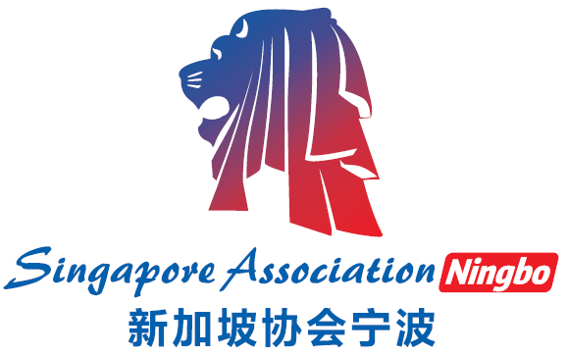
Singapore Association, Ningbo
新加坡协会（宁波）
Membership Application / Renewal Form 会员申请表
Membership Type 会员类别
□ Individual Membership 个人会员入会费  个人会员会费: RMB200/Year |  | □ Family Membership 家庭会员入会费  家庭会员入会费: RMB300/Year
Personal Particulars 个人基本情况
Surname姓： | Date of Birth 出生日期： |  |  |  | Nationality 国籍：
Name 名： | Sex 性别：□ Male 男 □Female 女 |  |  |  | Email Address 电子邮箱:
Company Name公司: | Position职位: |  |  |  | Contact Number 联系号码：
Family Particulars 家属基本情况
Name of Spouse 伴侣的名字： |  |  | Date of Birth 出生日期：
Sex 性别：□ Male 男 □Female 女 |  |  | Email Address 电子邮箱：
Nationality 国籍： |  |  | Contact Number 联系号码：
Names & Ages of Children (if any) 孩子的名字和年龄（若有）：

Signature签名： Date日期： |  |  |  | 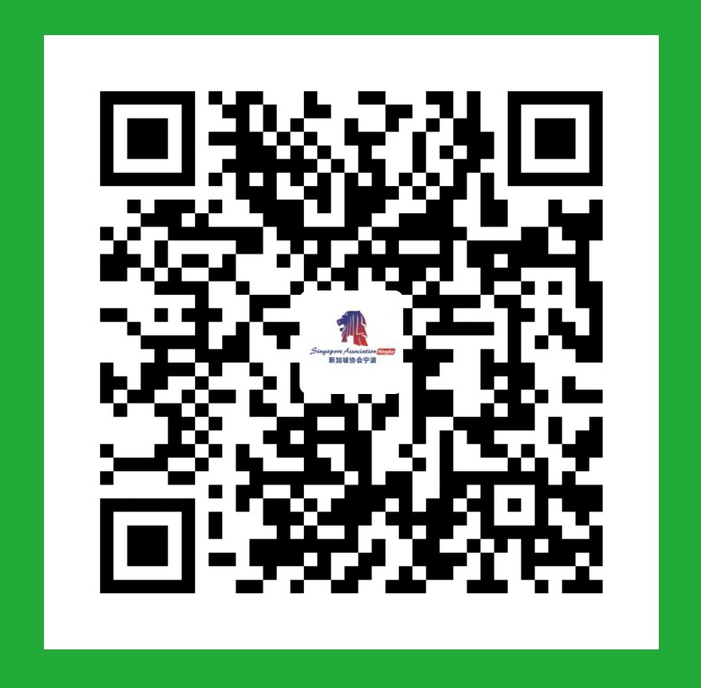  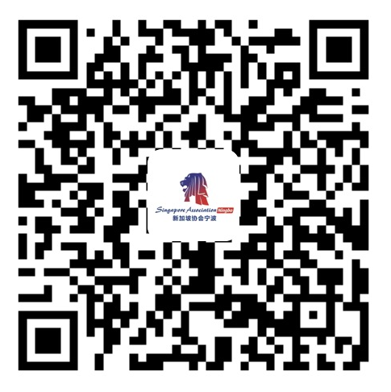  微信 支付宝  付款码 付款码
* Annual fee (年费) will be collected upon submission of the application and revised annually.

For Official Use by Club Only 会填写

Application Ref. No. 会员参考号码: Amount Collected: ___________ Date: __________

Membership No.: Recommended by: Payment Collected By:

_______________________

---------------------------------------------------------------------------------------------------------------------------------
Receipt: Payment made for membership application at Singapore Association, Ningbo

Payee: __________________________________________________________________ Amount Paid: ____________

Membership Type: ____________________ Date: ______________________ Membership Expiry: _______________

Signature (Representative of Singapore Association, Ningbo: __________________ Name: ___________________

